**Lab – 24: Create a one-time bypass in the Azure portal.**

**Objective:** The objective of this lab is –

* To create a one-time bypass in the Azure portal.

A one-time bypass allows a user to authenticate a single time without performing two-step verification. The bypass is temporary and expires after a specified number of seconds. In situations where the mobile app or phone is not receiving a notification or phone-call, you can enable a one-time bypass so the user can access the desired resource. In this lab, we are going to create a one-time bypass in the Azure portal.

**Prerequisite:** EMS Enterprise Mobility + Security E5.

**Steps:**

1. Sign in to your Azure Portal, by using the link - **https://portal.azure.com/**. Enter your credentials and click Sign In.

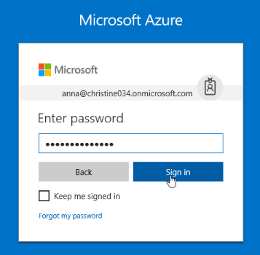

1. Microsoft Azure AD Dashboard will open.

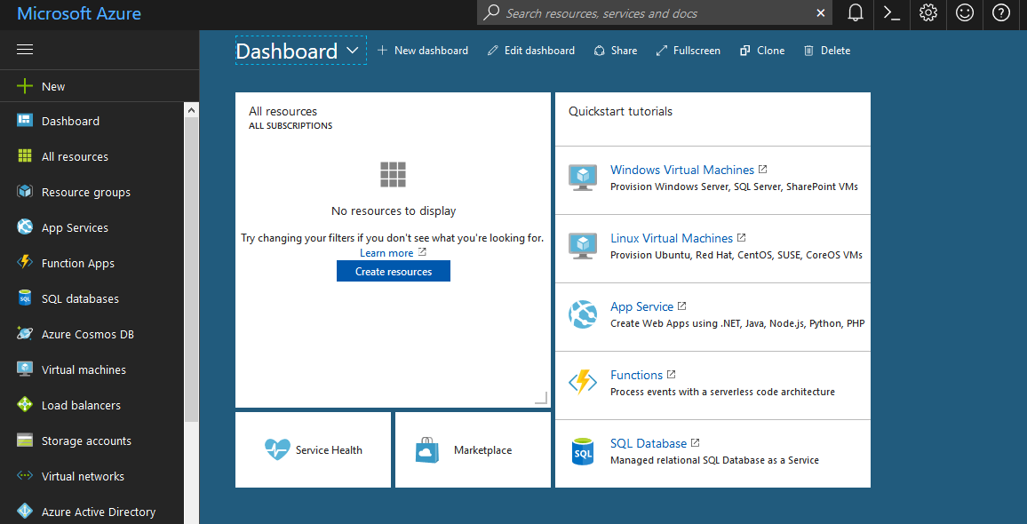

1. Navigate to **Azure Active Directory** > **MFA Server** > **One-time bypass**. This feature will allow a user to authenticate without performing two-step verification for a limited time. The bypass goes into effect immediately, and expires after the specified number of seconds. This feature only applies to MFA Server deployment.

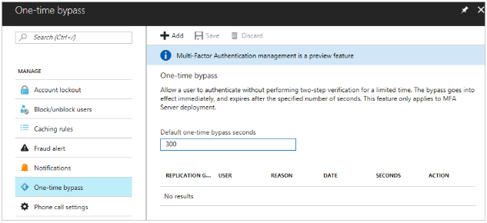

1. Select **Add** from the toolbar.



1. Enter the username (in the form of username@domain.com), the number of seconds that the bypass will exist, and the reason for the bypass.

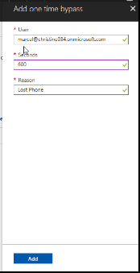

1. Select **Add**. The time limit goes into effect immediately, so the user needs to sign in before the one-time bypass expires.

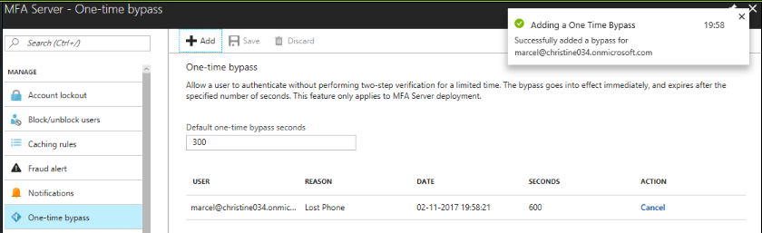

1. So, in this way you can create a one-time bypass in the Azure portal.